Basic SQL
S.No | Question | Query | Output
 | Display all records FROM the sales table. | SELECT * FROM sales; | 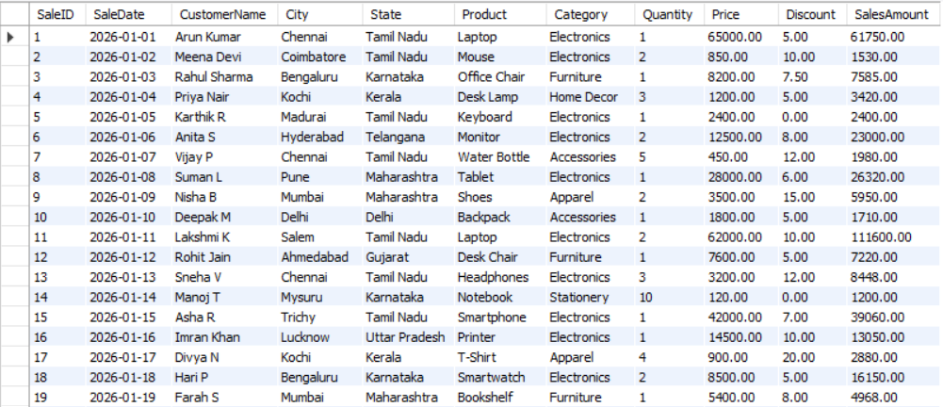
 | Display only CustomerName, Product, Quantity, and SalesAmount. | SELECT CustomerName, Product, Quantity, SalesAmount FROM sales; | 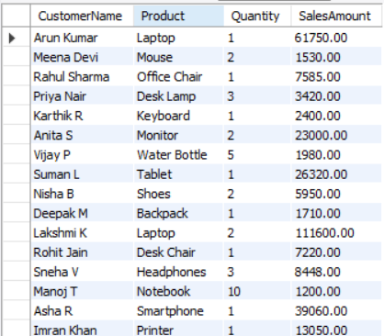
 | Find all sales made FROM Tamil Nadu. | SELECT SaleID,SaleDate,CustomerName,State FROM sales WHERE State = 'Tamil Nadu'; | 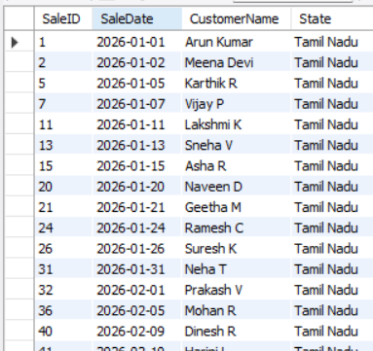
 | Find all sales WHERE SalesAmount is greater than ₹10,000. | SELECT SaleID,SaleDate,Product,Quantity,SalesAmount FROM sales WHERE SalesAmount > 10000 ; | 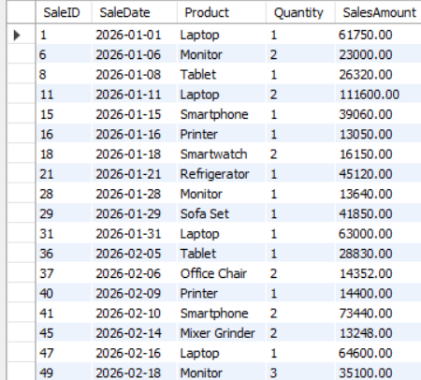
 | Display all products belonging to the Electronics category. | SELECT DISTINCT(Product),Category FROM sales WHERE Category = 'Electronics' ; | 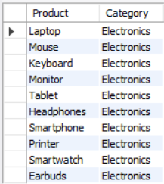
 | Find sales WHERE the quantity is between 5 and 20. | SELECT SaleID,CustomerName,Product,Quantity FROM sales WHERE Quantity BETWEEN 5 AND 20 ORDER BY Quantity; | 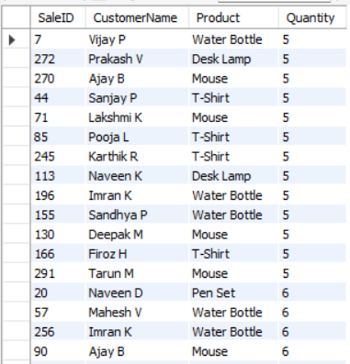
 | Display sales made FROM Chennai, Bangalore, and Hyderabad. | SELECT City,SUM(SalesAmount) FROM sales WHERE City IN ('Chennai', 'Bengaluru','Hyderabad') GROUP BY City ORDER BY City ; | 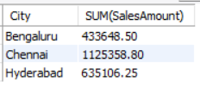
 | Find customers whose names start with the letter 'A'. | SELECT CustomerName FROM sales WHERE CustomerNameLIKE 'A%' ; | 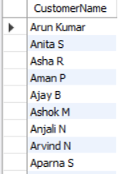
 | Display all unique cities FROM the sales table. | SELECT DISTINCT City,State FROM sales; | 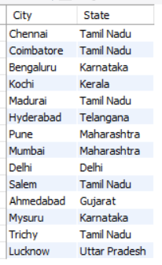
 | Display all records ordered by SalesAmount FROM highest to lowest. | SELECT * FROM sales ORDER BY SalesAmount desc; | 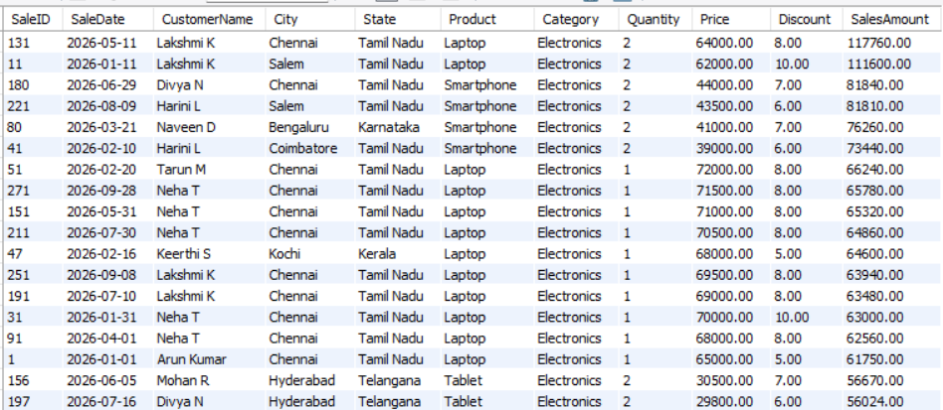

Aggregate Functions
S.No. | Question | Query | Output
 | Find the total sales amount. | SELECT SUM(SalesAmount) AS 'Total Sales',AVG(SALESAMOUNT) 'Average Sales',MAX(SALESAMOUNT) AS 'Maximum Sale', MIN(SALESAMOUNT) AS 'Minimum Sale' FROM sales; | 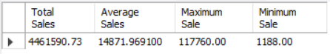
 | Find the average sales amount. | SELECT SUM(SalesAmount) AS 'Total Sales',AVG(SALESAMOUNT) 'Average Sales',MAX(SALESAMOUNT) AS 'Maximum Sale', MIN(SALESAMOUNT) AS 'Minimum Sale' FROM sales; | 
 | Find the maximum sales amount. | SELECT SUM(SalesAmount) AS 'Total Sales',AVG (SALESAMOUNT) 'Average Sales',MAX(SALESAMOUNT) AS 'Maximum Sale', MIN(SALESAMOUNT) AS 'Minimum Sale' FROM sales; | 
 | Find the minimum sales amount. | SELECT SUM(SalesAmount) AS 'Total Sales',AVG (SALESAMOUNT) 'Average Sales',MAX(SALESAMOUNT) AS 'Maximum Sale', MIN(SALESAMOUNT) AS 'Minimum Sale' FROM sales; | 
 | Find the total quantity sold. | SELECT SUM(Quantity) as 'Total Quantity',Product,Category FROM sales GROUP BY Product,Category ORDER BY 'Total Quantity'; | 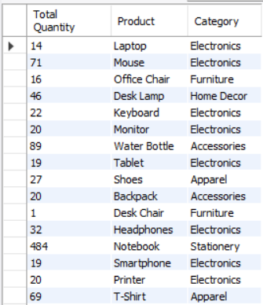
 | COUNT the total number of sales transactions. | SELECT COUNT(*) as 'Total Sales Transactions' FROM sales; | 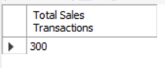
 | Find the total sales amount for the Electronics category. | SELECT SUM(salesamount) as 'Sales Amount', Category FROM sales WHERE category = 'Electronics' GROUP BY Category; | 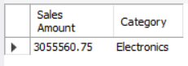
 | Find the average quantity sold per transaction. | SELECT AVG(quantity) as 'Average Quantity Sold' FROM sales; | 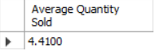
 | Find the total sales for Tamil Nadu. | SELECT SUM(salesamount) as 'Total Sales Amount',State FROM sales WHERE State = 'Tamil Nadu' GROUP BY state ORDER BY 'Total Sales Amount'; | 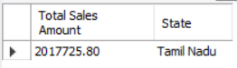
 | Find the number of unique customers. | SELECT COUNT(distinct CustomerName) as 'Unique Customer' FROM sales ; | 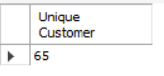

GROUP BY & HAVING
S.No. | Question | Query | Output
 | Find total sales for each category. | SELECT SUM(salesamount) as 'Total Sales Amount',category FROM sales GROUP BY category ORDER BY SUM(salesamount) desc; | 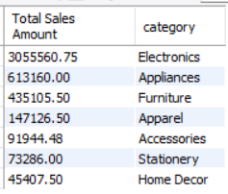
 | Find total sales for each city. | SELECT SUM(salesamount) as 'Total Sales Amount',city FROM sales GROUP BY city ORDER BY SUM(salesamount) desc; | 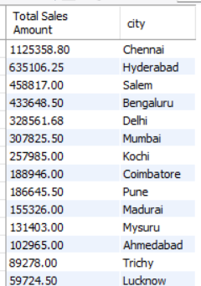
 | Find total sales for each state. | SELECT SUM(salesamount) as 'Total Sales Amount',state FROM sales GROUP BY state ORDER BY SUM(salesamount) desc; | 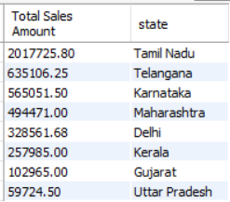
 | Find the total quantity sold for each product. | SELECT SUM(quantity) as 'Quantity Ordered',Product FROM sales GROUP BY Product ORDER BY SUM(quantity) desc; | 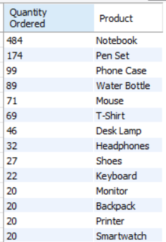
 | Find the average sales amount for each category. | SELECT ROUND(AVG(salesamount),2) as 'Average Sales Amount',category FROM sales GROUP BY category ORDER BY AVG(salesamount) desc; | 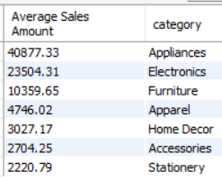
 | Find the number of transactions for each city. | SELECT COUNT(*) as 'Total Transaction',city FROM sales GROUP BY city ORDER BY COUNT(*) desc; | 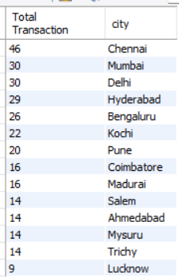
 | Find categories WHERE total sales are greater than ₹1,00,000. | SELECT SUM(salesamount) as 'Total Sales Amount' ,category FROM sales GROUP BY category having SUM(salesamount) > 100000; | 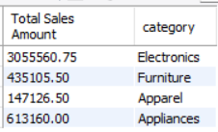
 | Find cities WHERE the average sales amount is greater than ₹15,000. | SELECT AVG(salesamount) as 'Average Sales Amount',city FROM sales GROUP BY city having AVG(salesamount) > 15000; | 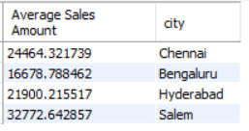
 | Find the top-selling product based on total sales. | SELECT SUM(salesamount) as 'Sales Amount' ,Product FROM sales GROUP BY PRODUCT ORDER BY SUM(salesamount) desc LIMIT 1; | 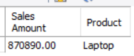
 | Find the state with the highest total sales. | SELECT SUM(salesamount) as 'Sales Amount' ,state FROM sales GROUP BY state ORDER BY SUM(salesamount) desc LIMIT 1; | 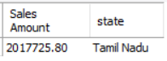

Date & Time Analysis
S.No. | Question | Query | Output
 | Find the total sales made during January 2026. | SELECT SUM(salesamount) as 'Total Sales Amount',MONTHNAME(saledate) FROM sales WHERE MONTHNAME(saledate) = 'January' GROUP BY MONTHNAME(saledate) ORDER BY SUM(salesamount) desc; | 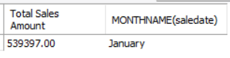
 | Find the total sales made during Independence Day month – August 2026. | SELECT SUM(salesamount) as 'Total Sales Amount',MONTHNAME(saledate) FROM sales WHERE MONTHNAME(saledate) = 'August' and YEAR(saledate) = 2026 GROUP BY MONTHNAME(saledate) ORDER BY SUM(salesamount) desc; | 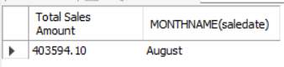
 | Display sales made in the last 30 days. | SELECT * FROM sales WHERE saledate >= current_date - INTERVAL 30 DAY and saledate < current_date ORDER BY saledate desc ; | 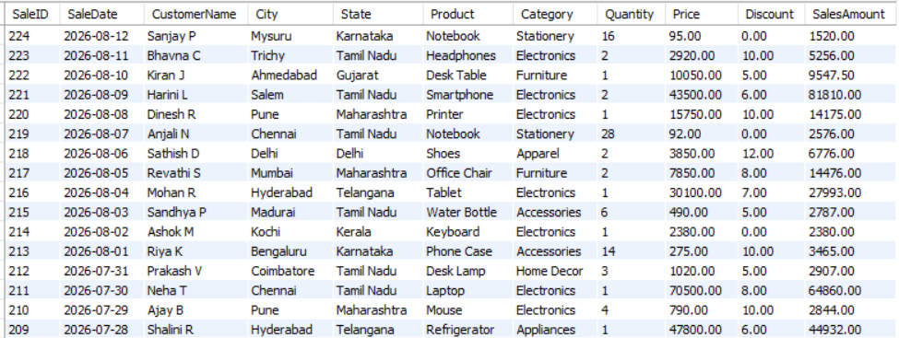
 | Find total sales for each month. | SELECT SUM(salesamount) as 'Sales Amount', MONTHNAME(saledate) FROM sales GROUP BY MONTH(saledate),MONTHNAME(saledate) ORDER BY MONTH(saledate); | 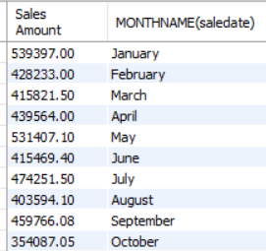
 | Find the number of transactions for each month. | SELECT COUNT(*) as 'Sales Transaction', MONTHNAME(saledate) as 'Month' FROM sales GROUP BY MONTH(saledate), MONTHNAME(saledate) ORDER BY MONTH(saledate); | 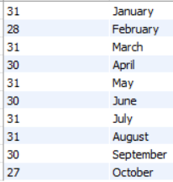
 | Find the highest-sales month. | SELECT SUM(salesamount),MONTHNAME(saledate) FROM sales GROUP BY MONTH(saledate), MONTHNAME(saledate) ORDER BY SUM(salesamount) desc LIMIT 1; | 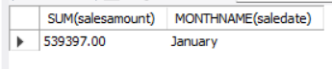
 | Find the lowest-sales month. | SELECT SUM(salesamount),MONTHNAME(saledate) FROM sales GROUP BY MONTH(saledate), MONTHNAME(saledate) ORDER BY SUM(salesamount) LIMIT 1; | 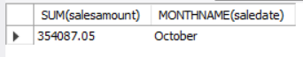
 | Find total sales for each year. | SELECT SUM(salesamount) as 'Sales Amount' , year(saledate) as 'year' FROM sales GROUP BY year(saledate) ORDER BY SUM(salesamount) desc ; | 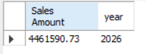
 | Find sales made on weekends. | SELECT *,dayname(saledate) FROM sales WHERE weekday(saledate) >= 5; | 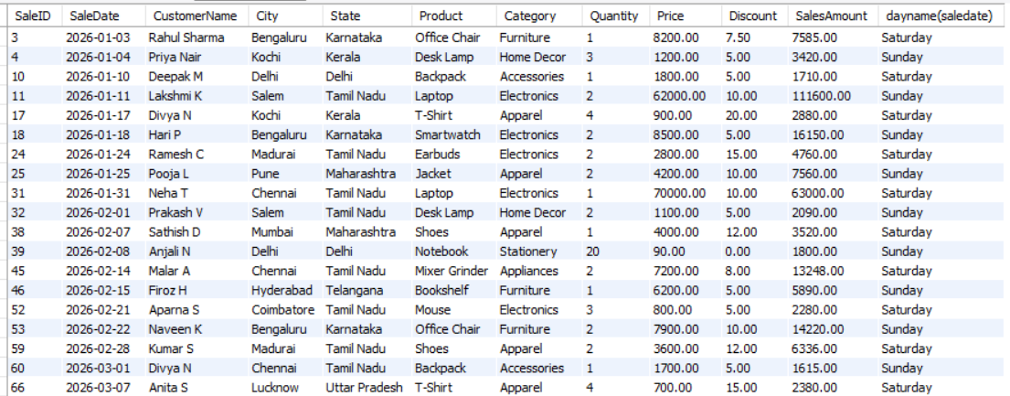
 | Find the number of sales transactions made on each day of the week. | SELECT COUNT(*) as 'Total Transaction' ,dayname(saledate) as 'Day of Week' FROM sales GROUP BY DAYOFWEEK(SaleDate),dayname(saledate) ORDER BY dayofweek(saledate) ; | 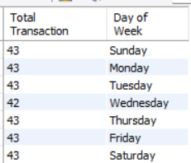

CASE Statement
S.No. | Question | Query | Output
 | Create a SalesLevel column: Sales ≥ ₹50,000 → High, Sales ≥ ₹20,000 → Medium, Otherwise → Low | SELECT saleid,salesamount,  case  when salesamount >= 50000 then 'High'  when salesamount >= 20000 then 'Medium'  else 'Low'  end as 'Sales_Level'  FROM sales; | 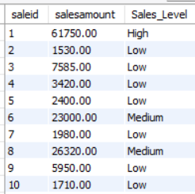
 | Create a QuantityLevel column: Quantity ≥ 20 → Bulk, Quantity ≥ 10 → Medium, Otherwise → Regular | SELECT saleid,quantity,  case  when quantity >= 20 then 'Bulk'  when quantity >= 10 then 'Medium'  else 'Regular'  end as 'Quantity Level'  FROM sales ORDER BY quantity desc; | 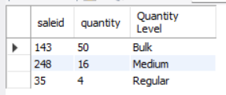
 | Categorize products based on sales amount. | SELECT Product, COUNT(*) AS 'Total Transactions', SUM(SalesAmount) AS 'Total Sales Amount',  CASE  WHEN SUM(SalesAmount) >= 50000 THEN 'High'  WHEN SUM(SalesAmount) >= 20000 THEN 'Medium'  ELSE 'Low'  END AS `Sales_Level`  FROM sales  GROUP BY product  ORDER BY `Total Sales Amount` DESC; | 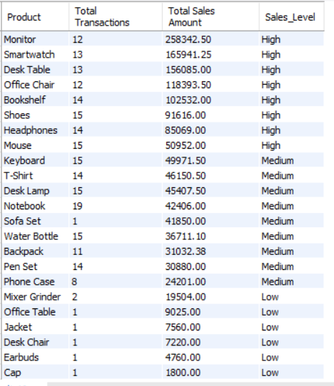
 | Calculate a DisCOUNTCategory using: DisCOUNT ≥ 20% → High DisCOUNT, DisCOUNT ≥ 10% → Medium DisCOUNT, Otherwise → Low DisCOUNT | SELECT product,category,disCOUNT,  case  when DisCOUNT >= 20 then 'High DisCOUNT'  when DisCOUNT >= 10 then 'Medium DisCOUNT'  else 'Low DisCOUNT'  end as 'DisCOUNT Category'  FROM sales GROUP BY product,category,disCOUNT,`DisCOUNT Category` ORDER BY disCOUNT desc; | 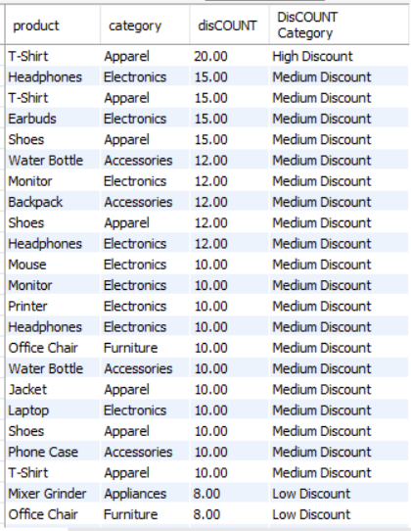
 | Find the number of transactions in each sales level. | SELECT  CASE  WHEN salesamount >= 50000 then 'High'  WHEN salesamount >= 20000 then 'Medium'  ELSE 'Low'  END as 'Sales Level',  COUNT(*) as 'Transaction'  FROM sales GROUP BY `Sales Level` ORDER BY `Sales Level` desc; | 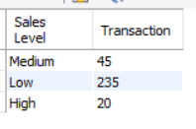

Subqueries
S.No. | Question | Query | Output
 | Find customers whose sales amount is greater than the average sales amount. | SELECT CustomerName, SUM(SalesAmount) AS TotalSales  FROM sales  GROUP BY CustomerName  HAVING SUM(SalesAmount) > (  SELECT AVG(CustomerTotal)  FROM (  SELECT SUM(SalesAmount) AS CustomerTotal  FROM sales  GROUP BY CustomerName  ) t  ); | 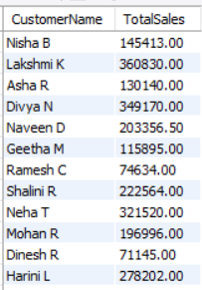
 | Find products whose total sales are greater than the average product sales. | SELECT Product, SUM(SalesAmount) AS TotalSales  FROM sales  GROUP BY Product  HAVING SUM(SalesAmount) > (  SELECT AVG(ProductSales)  FROM (  SELECT SUM(SalesAmount) AS ProductSales  FROM sales  GROUP BY Product  ) t  )  ORDER BY TotalSales DESC; | 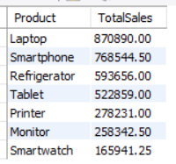
 | Find the product with the highest sales amount. | SELECT Product, SUM(SalesAmount) AS TotalSales  FROM sales GROUP BY Product ORDER BY TotalSales DESC  LIMIT 1; | 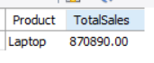
 | Find the second-highest sales amount. | SELECT DISTINCT SalesAmount,Product  FROM sales  ORDER BY SalesAmount DESC  LIMIT 1 OFFSET 1; | 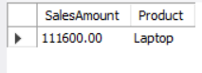
 | Find customers who have made more sales than the average customer sales. | WITH customer_totals AS (  SELECT CustomerName, SUM(SalesAmount) AS TotalSales  FROM sales  GROUP BY CustomerName  )  SELECT CustomerName, TotalSales  FROM customer_totals  WHERE TotalSales > (SELECT AVG(TotalSales) FROM customer_totals)  ORDER BY TotalSales DESC; | 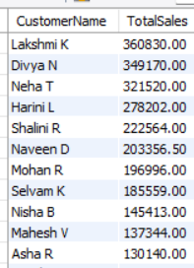
 | Find the city having the highest total sales. | SELECT City, SUM(SalesAmount) AS TotalSales  FROM sales  GROUP BY City  HAVING SUM(SalesAmount) = (  SELECT MAX(CitySales)  FROM (  SELECT SUM(SalesAmount) AS CitySales  FROM sales  GROUP BY City  ) t  ); | 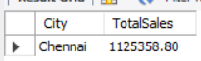
 | Find all transactions having sales greater than the maximum sales of Bengaluru. | SELECT SaleID, SaleDate, CustomerName, City, SalesAmount  FROM sales  WHERE SalesAmount > (  SELECT MAX(SalesAmount)  FROM sales  WHERE City = 'Bengaluru'  ); | 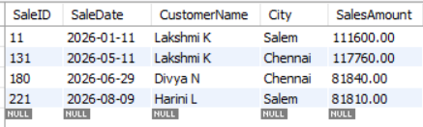
 | Find products whose price is greater than the average product price. | SELECT Product, Category, Price  FROM sales  WHERE Price > (SELECT AVG(Price) FROM sales)  ORDER BY Price DESC; | 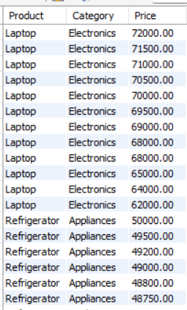
 | Find the customer with the highest total purchase amount. | SELECT CustomerName, SUM(SalesAmount) AS TotalPurchaseAmount  FROM sales  GROUP BY CustomerName  ORDER BY TotalPurchaseAmount DESC  LIMIT 1; | 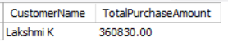
 | Find the second-highest-selling product. | SELECT Product, SUM(SalesAmount) AS TotalSales  FROM sales  GROUP BY Product  ORDER BY TotalSales DESC  LIMIT 1 OFFSET 1; | 